**VUIS CONSULTING PTY LTD.**

**BCO6672**

**The Information Systems Professional**

**Presentation Assignment: Victoria Secret case**

*Lecturer: Dr Maria Prokofiev*

*Students:*

*Bich Phuong Luu - s4600099*

*Llia Nebas - s4621601*

# Executive summary

This report will show the data analyse for Vitoria Secret brand, comparing with data of other brands as B.Tempte’d, Calvin Klein and Hanky Panky, taken from Kaggle website to help managers in pricing decisions, finding customer preferences and customer groups analysis for product ranges, and then from these analyses, we will provide data driven predictive insights and marketing strategies for Victoria Secret brand. To clean the massive data and level them to lower hierarchy, we use the support software Tableau Prep, and then Tableau Desktop to create dashboards and Data Visualizations. There are four parts in this report, firstly some background information about Victoria’s Secret will be given in introduction part, and summary data sources, data variables and data preparation in the methodology part. Then, data will be used to create dashboards to give analysis about price decision for product ranges and customer preferences. Lastly, some recommendations will be discussed after giving data driven predictive insights.

Contents

Executive summary 2

I- Introduction 4

II- Methodology 4

III- Customer preferences for brands/product ranges and customer groups analysis 5

IV- Business insights and communication - Pricing decisions for brands/product ranges 9

Data driven predictive insights in relation to the above 11

Recommendations 11

# Introduction

Starting with some background information about Victoria's Secret, it is an American clothing, and beauty retailer known for their high visibility marketing and branding. The company became one of the most popular because of high quality products, and regular shows all over the world regarding to new collection of clothing. However, Victoria’s Secret is not the only one on the market that offers essentials to the population. Other well-known brands like Calvin Klein, Hanky Panky, Aerie, and BTempted also offer same kinds of products, so the market is divided by giants. Moreover, they not only trying to sell their products directly to customers through their off stores in over the word, but also through other popular online channels from aggregates as Amazon, Macys and Nordstrom as well. Therefore, we retrieved the data from all the mentioned sources to research the previously mentioned issues.

# Methodology

The data sources taken from Kaggle website, in this analysis, we use data sources about Victoria Secret, Calvin Klein, B.temp’d, Amazon, Macys and Nordstrom, Hanky Panky to take the prices, the review count and rating of their products on websites.

Victoria secret dataset had a huge product assortment, however it was decided to sort all the products by categories, so each item could be related to a certain category. Therefore, since Victoria’s Secret is famous for good quality underwear, three categories were created, such as Bra, Panty, and others. Moreover, the same way competitors and resellers items were sorted. Then, to continue having lower hierarchy and to have the detailed and deeper analyses from Bra product lines, the total of products was divided to 5 groups basing on their prices, products having same price around 1$-15$, 16$-30$, 31$-45$, 45$-60$ or over 60$ will be included in same groups.

Data preparation steps: Clean data, remove errors and unnecessary data, union data, aggregate data to remove duplication data, replace and group fields. All data sources about Victoria Secret, Calvin Klein, B.temp’d, Amazon, Macys and Nordstrom, Hanky Panky are cleaned by Tableau Prep:

* Adjust right data type for variables, such as review count, rating, price variables whole number, not string
* Group and replace product_category to 3 types: Bras, Panties and others for each resource. In this case, we just use data about Bra products.
* Union all sources in one
* Remove all fields not to use and check their punctuation errors, format for each field
* Aggregate data of union resource to remove duplication data, take calculation: Average for prices, rating and review count.
* Make a duplication field of Prices variable, named Price ranges fields. Group and replace all value 1-15, 16-30, 31-45, 45-60, over 60 in one group, change type data to String and renamed all group to 1$-15$, 16$-30$, 31$-45$, 45$-60$ and over 60$

# Customer preferences for brands/product ranges and customer groups analysis

Today, Victoria secret provide many types of products in market as BRAS, PANTIES, LINGERIE, SLEEP, SPORT, LOUNGE, BEAUTY, ACCESSORIES and SWIM . However, BRAS is the main and most well-known product of Victoria Secret with 176 products, and 24,722 reviews through all channels, accounting 60,15% total reviews of Victoria Secret brand. (Figure 1).

Figure1: Total reviews of product types from Victoria Secret brand.

To reflect this, the reviews were counted regarding each product type. According to the graph people are more subjected to buy Bra wear rather than underwear or other items. Thus, it may be concluded that if from all the product range customers buy more Bras then other things it worth to concentrate and continue the research on the Bra market. Due to its prominence, we decided to just focus on Bras types of Victoria Secret to provide more deeper analytics in this report.

The best seller items Victoria’s secret offers, basing on the customers’ feedback on websites will be showed in figure 2. The chart results are based on the review count because it reflects the number of people who purchased the item directly from manufacturer or through the reseller. The table shows the heatmap and reflects the data from the best-selling item to ones that are not popular. As we can see, Body shape bra has the highest number of reviews which tells us that the item was bought not less than 631 times. So, the red and ginger area shows the range of products that were bought many times and considered to be popular in stores. It gives the idea that company should develop this product line more and motivate people to buy them more.

However, when comparing to other brands, including B.temp’d and Calvin Klein in market to see top popular 20 Bras product, the first seven positions belongs to product of B.temp’d, and no.1 Victoria Secret come up to the 8th position, it shows that even Victoria Secret has a big market but they need put more efforts to improve their product lines to have the no 1 product lines in market, comparing to others. (figure 2)

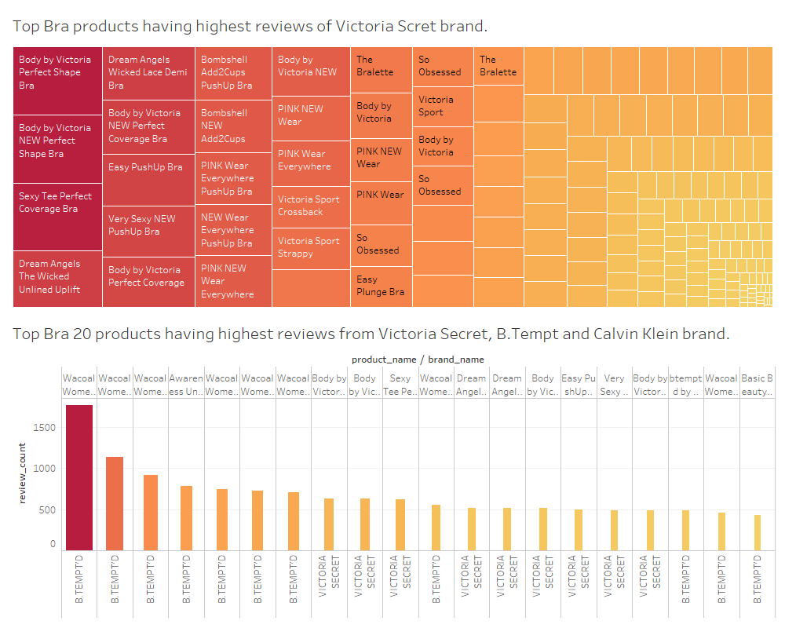

Figure 2: The dashboard about top Bra product of Victoria Secret and other brands from B.Tempt’d and Calvin.

Then, to see which the market Victoria Secret target, we cran see the pie chart below, the majority of the company products are in affordable range, 50% of total catalogue or 88 items have price in between 16-30$. (figure 3)

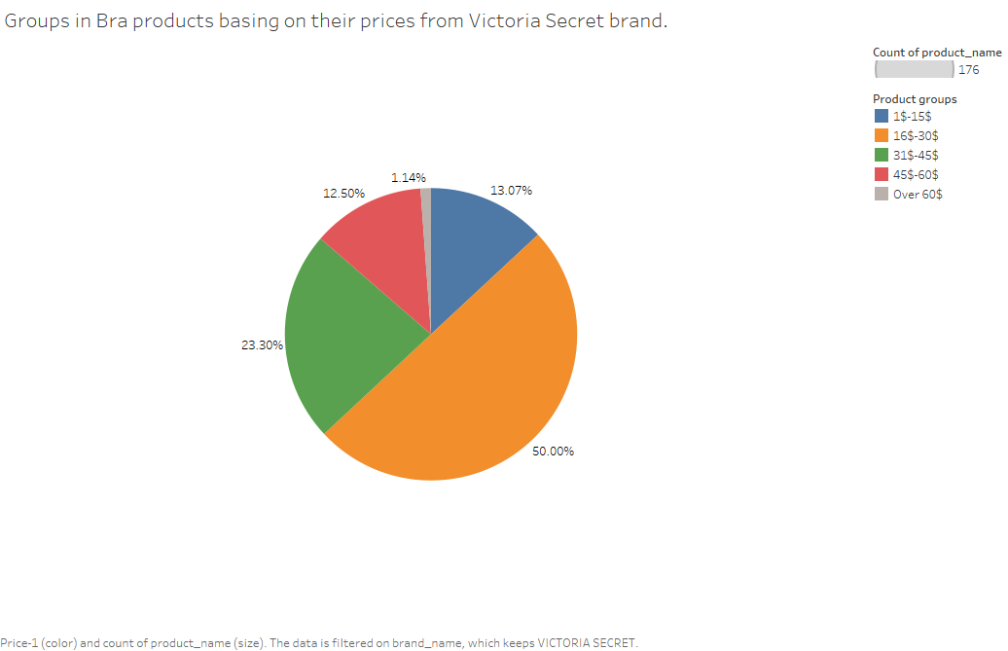

Figure 3: % of product Bra groups, comparing to total Bra products in Victoria Secret.

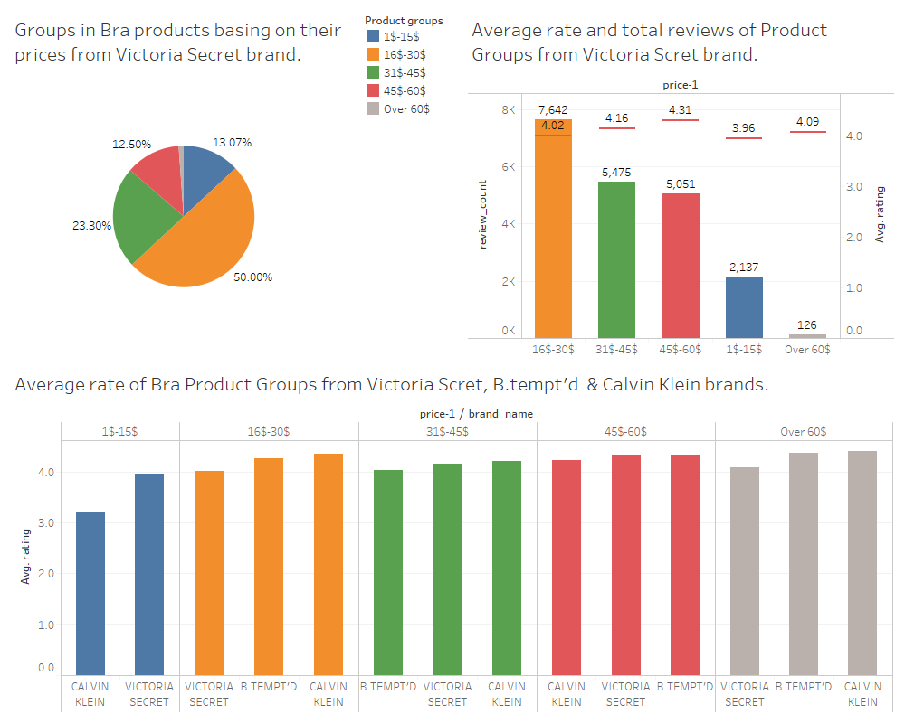We continue to the next dashboard (figure 4) that shows what price range the best seller for Victoria’s Secret is and what is the average rating for each price range to define its customer groups and their references. After visualizing the data, we can see that the top-rated category is products from 45$-60$ category, and sales are quite impressive as well. However, the major good sale is happening in the 16$-30$ category items and it suffice to say that rating is not low as well. As was expected, the lowest rating is assigned to 1$-15$ items and the sales are not high as well. Additionally, the loves turnover is noted at the over 60$ category. Thus, it can be said that since the company covers this low and middle niche of the market it attracts more potential customers and make their goods affordable to everyone. However, before starting this, we also need to compare the same hypothesis with other top competitors such as B.Tempted and Calvin Klein, we decided to visualise the Bra market data of Victoria Secret and its competitors by and average rating. It can be seen from the graph that Victoria secret has the lowest rating compared other companies; however, other companies have bigger rating. Therefore, future in-depth data exploration required before making any final statements. (figure 4)

Figure 4: Dashboard comparing product groups of Victoria Secret to other brands in term focusing to Average rating.

# Business insights and communication - Pricing decisions for brands/product ranges

The next step will be to analyse the company segment regarding to the price range, leading price decision. According to the seen results, let’s compare Victoria secret with its competitors according to the average price and average rating of all the items from their catalogue (figure 5). As it can be seen, Victoria Secret has low average review, compared to competitors with low the average price of all the items. Calvin Klein and B.Tempted both have good average product rating; however, the average price of all the catalogue items of Calvin Klein is 35.3 when B.Tempted is 44.3. Hanky Panky has the highest average price and rating in this chart; however, since the data regarding to the review count of Hanky Panky in figure 6 is insufficient, this company cannot be considered as a leader at the high-price segment. (Figure 5)

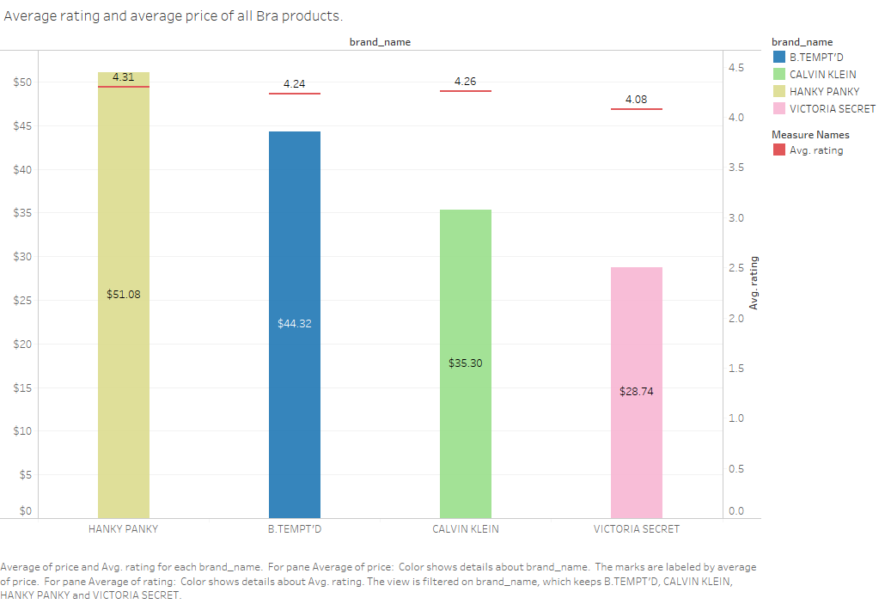Figure 5: Average rating and average price of Bra products from Victoria Secret, B.Tempt’d, Calvin Klein and Hanky Panky.

Now we consider the bar chart showing the reviews and rating comparison among all the key competitors through product groups. At the first column with the lowest price range from 1-15$ , it is clear to notice that Victoria secret is the leader according to total review count and average rating. Same situation can be seen at the next range 16-30$ even though the overall rating of items in this group are lower than competitors. Also, some situation can be seen at the 31-45$ column. However, everything changes when it comes to 46-60$ and over 60$. As it can be seen, the major player of this 2 section is B.tempted with bigger amount of reviews and high average rating. Same results can be recreated using heat map. Further exploration can be made regarding to why Victoria’s Secret is not the leading one at this section, but in-depth review analyzation will be required. (figure 6)

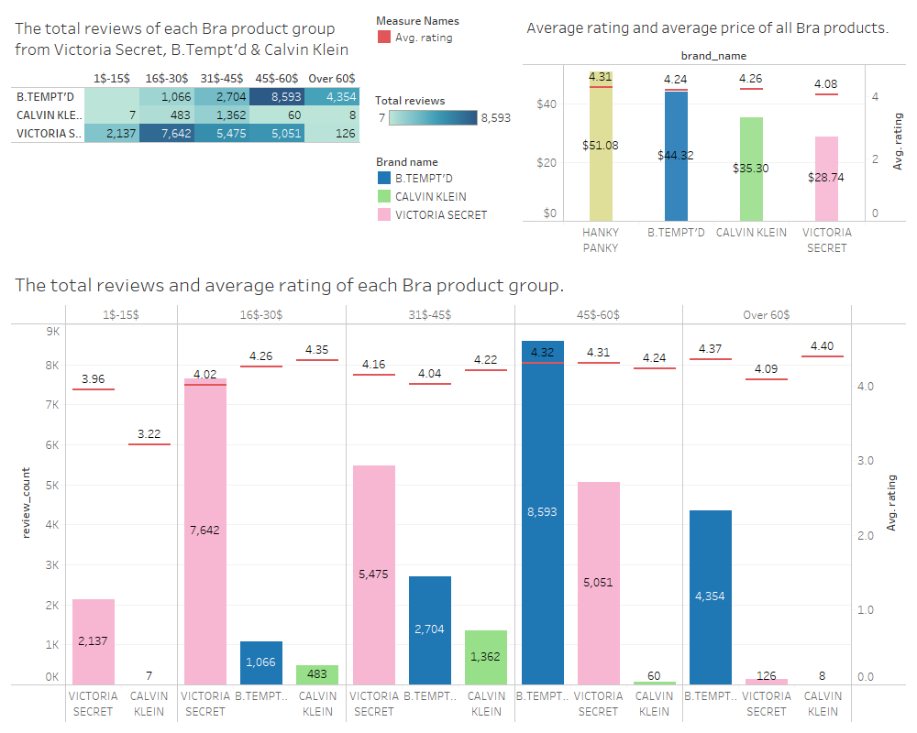

Figure 6: Dashboard about the relationship between prices with sales volume and rating of Victoria Secret, Calvin Secret and Calvin Klein brand.

# Data driven predictive insights in relation to the above

In term of customer references, Victoria Secret has lowest average rating from customer or even in each product groups, comparing to some other competitors in market. Therefore, Victoria Secret need to put more effort in improving their quality of products, not just quantity or sales volume. Otherwise, it will not remain loyal customers and loss their share market to other competitors. (figure 7)

In term of price decision, as analysed above, generally Victoria Secret focus on market with low and medium price product around 16$-45$. There are some predictive insights and prices strategies, basing on the satisfaction of customer and their concern about products, comparing to Calvin Klein and B.temp’d. (figure7)

- Group of products having price from 1$-15$, Victoria Secret has dominate this market, comparing to Calvin Klein and B.temp’d, so it can make a Price bundling strategy in the future, which means offer their customer more set of products and accessories with lower prices. Buying the set or pack with low prices comparing to buy separately can attract customers in this market

- Group of products having price from 16$-30$ and 31$-45$, although Victoria Secret having the biggest total reviews and also dominate this market, the competitors have advantages about the rating form customer, so Victoria Secret need to consider to launch a new product in this price range or lower price at the first time but having higher quality to compete to other with same target market and retain exit customers. This competitive pricing for new product can help Victoria Secret attain market quickly. Otherwise, with same price range, customer can easy move to B.temp’d or Calvin Klein product if they have higher rating.

- Group of products having price from 45$-60$: Although the feedbacks of customers for Victoria Secret and B.tempt’s is similar, approximately 4.3 rating, B.tempt’d has the highest share. Then if Victoria Secret wants to gain this market share in the future, it should consider to a competitive pricing strategy with discount and promotion strategy to gain this share market to attach new customers in this market.

- Group of products having price over 60$: It seems be a new market with Victoria Secret with the low rating and less concern from customer in this level. The reason is that, Victoria Secret may set up a high price for their luxury line product with low quality, called market-plus pricing strategy in the first time launching them. Some of famous brand can do that to take maximum advantages and profits from loyal and curious customers with this brand. However, after that, Victoria need to define again this line product, it should be decrease prices to lower prices groups, to adapt with their quality and luxury customer’s requirements and also launch new product having able competing with B.temp’d

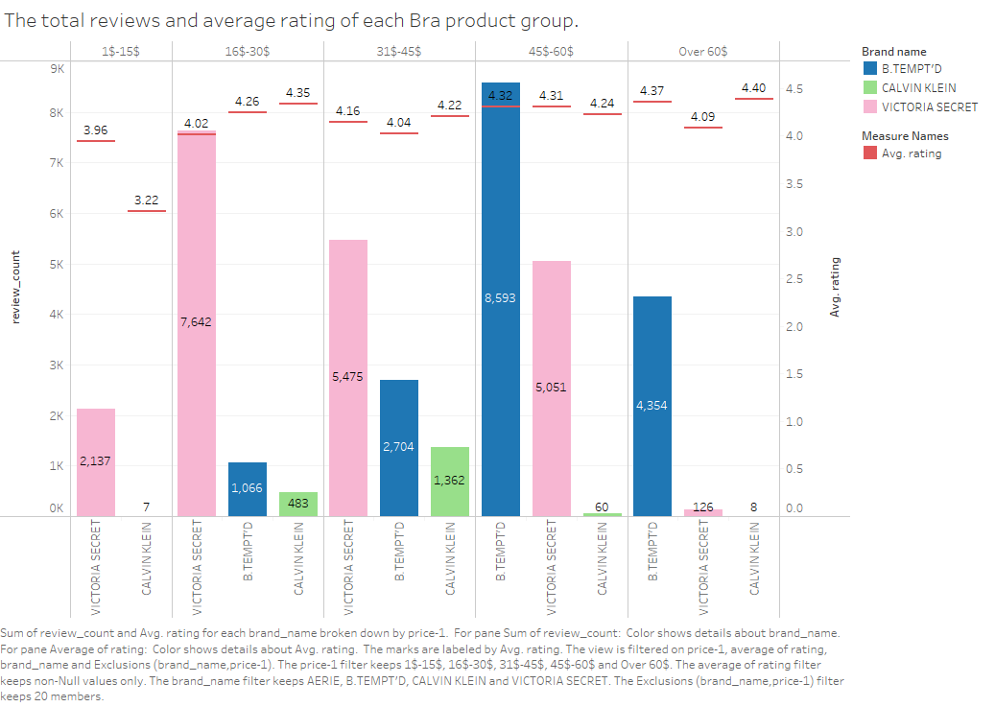

Figure 7: Bra Product groups of Victoria Secret, Calvin Klein and B.temp’d in comparing to average rating and total reviews.

# Recommendations and conclusion

It may be concluded that the majority of buyers at the underwear industry are more subjected to buy Bras. The biggest item demands were found at the 16-30$ and 46-60$ and moderate demand at 31$ - 45$ price range. Moreover, Victoria’s Secret items are the dominant at the price level from 1$ to 45$. In order to increase Bra sales at 46-60$ price range with the existing 22 items the review analysis should be done to identify company’s weakness towards competitors. Thus, in order to get bigger share of the market, Victoria’s Secret has to compare its catalogue to competitors and find weaknesses that should be eliminated and represented to people. Also, some price change policy as marketing-plus pricing, competitive pricing or price bundling, and marketing strategies may be applied to items that do are sold slowly to boost the sales. Newer the less, the contemporary market share of the Victoria Secret company is in positive situation but to make it better the above-mentioned recommendations should be considered.